**Getting started**

**With HTML**

**Assignment**

**Question and answer**

**Question 1: Write a simple program in HTML that displays the heading “HTML defines the content and structure of your website” on the web browser?**

**Answer 1:**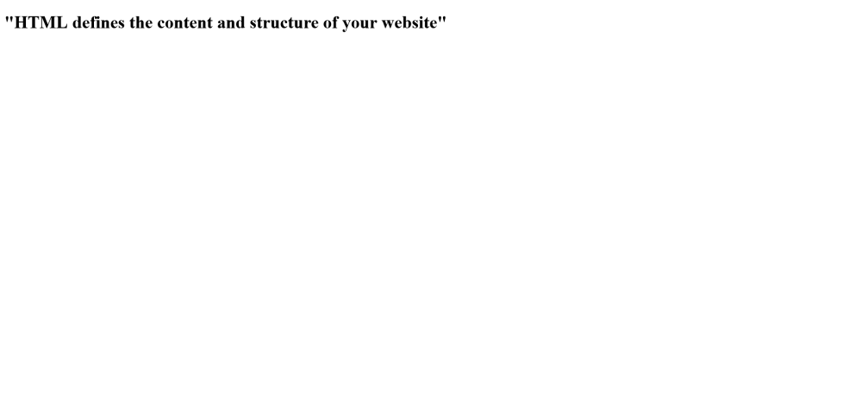

**Question 2: Explain the purpose of comments in HTML and provide an example of how to use comments in an HTML document?**

**Answer 2: The comment tag is used to insert comments in the source code. Comments are not displayed in the browsers.**

**You can use comments to explain your code, which can help you when you edit the source code at a later date. This is especially useful if you have a lot of code.**

**Example: <!-- Write your comments here -->**

**Question 3: Write an HTML program that includes a heading, a paragraph of text, a horizontal line, and a line break. Arrange these elements to create a simple web page layout?**

**Answer 3:** 

**Question 4: Write a short note on tag and element with an example?**

**Answer 4: HTML TAG :HTML tags are the keywords on a web page that define how your web browser must format and display your web page.**

**There are a total of 100 HTML tags. We will divide them into categories and discuss the important ones in this article.**

**Head Tag**

**The head tag <head> contains all the elements describing the document.**

**Title Tag**

**The title tag <title> specifies the HTML page title, which is shown in the browser’s title bar.**

**Body Tag**

**The body tag <body> is where you insert your web page’s content.**

**Paragraph Tag**

**A paragraph tag <p> is used to define a paragraph on a web page.**

**Heading Tag**

**The HTML heading tag is used to define the heading of the HTML document. The <h1> tag defines the most important tag, and <h6> defines  the least.**

**For example, <html> is the opening tag and </html> is the closing tag.**

**HTML ELEMENT : An HTML element is defined by a start tag, some content, and an end tag.**

**The HTML element is everything from the start tag to the end tag:**

**<tagname>Content goes here...</tagname>**

**In HTML, an element is a section of an HTML document. Some HTML elements represent visible components on a web page, such as text, images, or buttons, while others denote different sections of the page or provide meta-information about the document.**

**There are three kinds of HTML elements: normal elements, raw text elements, and void elements.**

**Examples of some HTML elements:**

**<h1>My First Heading</h1>**

**<p>My first paragraph.</p>**

**Question 5: What is the DOCTYPE declaration in HTML?**

**Answer 5: All HTML documents must start with a <!DOCTYPE> declaration.**

**The declaration is not an HTML tag. It is an "information" to the browser about what document type to expect.**

**In HTML 5, the declaration is simple:**

**<!DOCTYPE html>**